**Project Title: Smart Shopper – Global Price & Budget Assistant**

**Concept Overview**

**Smart Shopper** is a Node.js-based web application that allows users to search for products online and compare their prices across different currencies. The app helps travelers, freelancers, and international shoppers better understand the cost of items in their local currency and stay within budget.

Users can:

* Search for products (e.g., headphones, laptops) and view details like name, price, image, and vendor
* Convert product prices into a preferred currency (e.g., CAD to USD or EUR)
* Save products to a **watchlist**
* Set a budget and get notified if they go over their limit

This concept is cohesive and solves a real-world problem by combining two public APIs. It may also integrate open product data (optional) for bonus relevance.

**APIs to Be Used**

1. **API Ninjas – Amazon Product Search API**  
    https://api-ninjas.com/api/amazon
   * Used to fetch product details like name, price, image, and link to the product page.
2. **Frankfurter Exchange Rates API**  
   <https://www.frankfurter.app/>
   * Used to convert prices between international currencies.

**Optional Open Data Source**

**Open Food Facts (for eco-labels or nutrition if product is grocery-related)**  
https://world.openfoodfacts.org/data

**MVP (Minimum Viable Product)**

* Product search form
* Display results with product title, image, and price
* Currency dropdown to convert prices into user's preferred currency
* Add-to-watchlist functionality using localStorage
* Display total cost of selected items
* Set and monitor a simple budget threshold

**Pages**

| **Page** | **Description** |
| --- | --- |
| / (Home) | Welcome page with product search bar |
| /results | Shows product cards and price conversions |
| /watchlist | Displays saved products and current total cost |

**Wireframes *(optional but recommended)***

* **Home Page**: Search bar + currency dropdown
* **Results Page**: Product cards in a grid (image, title, price, “Add to Watchlist” button)
* **Watchlist**: List of saved products with total cost, and a budget tracker.

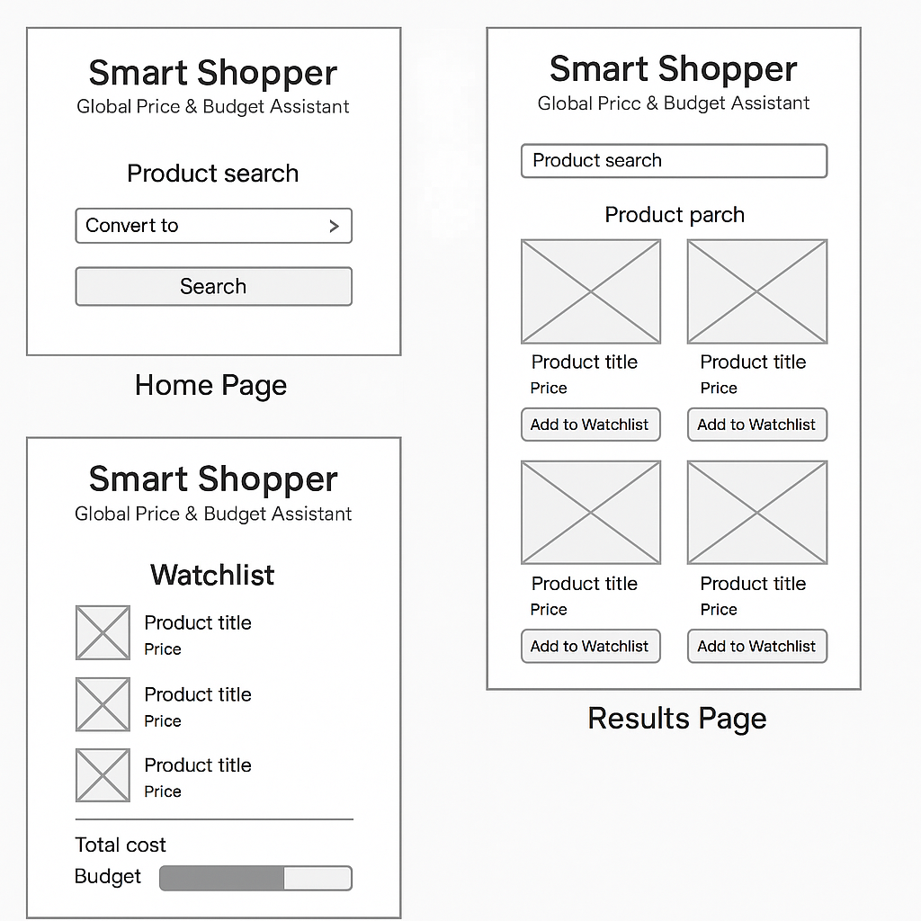

**Summary**

Smart Shopper brings together product data and real-time currency conversion in a meaningful, user-friendly way. It’s useful, realistic, and aligns with modern consumer behavior. The APIs work together naturally to support budgeting and international price comparison.